MSE 23000 Homework Assignment – Week 2 (10 pts)
Crystal Planes & Directions and Characterization

Over the next week, think about the following problems and provide your responses as prompted below using this document as a template. Responses can be typed and/or inserted as scans or images (e.g., of hand-written calculations or sketches). These questions are reflective of typical exam questions – hence, the students who complete their homework assignments are the best prepared for their upcoming exams. Additionally, you are encouraged to attempt all homework problems before attending your weekly recitation so that you are prepared to ask questions and seek guidance & hints from your recitation instructor. This assignment is worth 10 points and will be graded for completion only. Submit your assignment as a PDF by using the appropriate link on Brightspace. You may choose to complete this assignment independently or work in groups but all submitted responses must be unique/your own work. Correct responses will be discussed in your next recitation lecture.

(2 pts) 1. Label the following directions and planes.

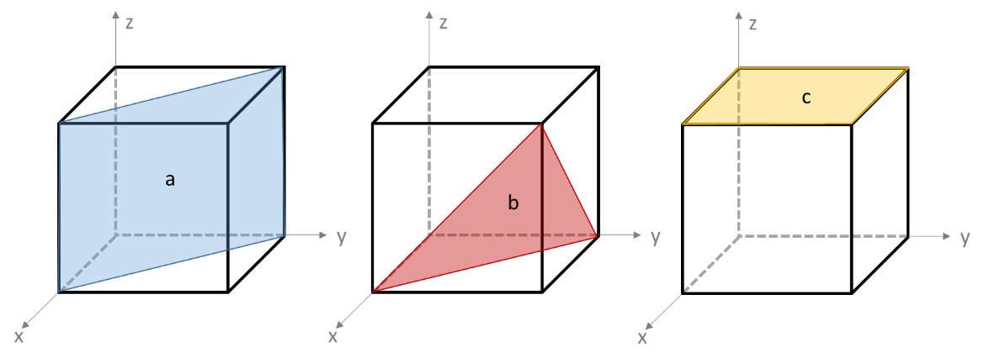
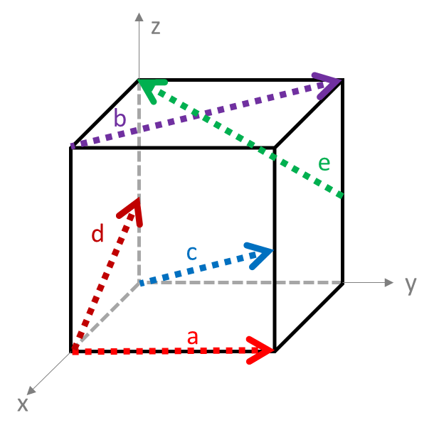
Directions:
(a)110
(b)110
(c)000
(d)102
(e)011
Planes:
(a)110
(b)111
(c)001

(1 pt) 2. This question will test your understanding of the face-centered cubic (FCC) unit cell. Use the following figure, which you may wish to copy into PowerPoint for sketching purposes.
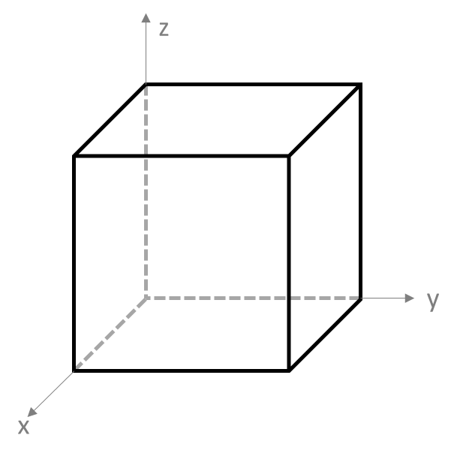
- Draw the , and the directions.
- Draw in the (111) plane.
- For the (111) plane, draw a new sketch of the plane that also shows the position of the atoms that are intersected by that plane (hint: you should draw six atoms to do this).

(1 pt) 3. The following x-ray diffraction pattern is from a sample of an “unknown” metal. The wavelength of the x-ray radiation used for the measurement was 0.15405 nm. Each peak within the diffraction pattern has already been labeled with the known “Peak Index” (i.e., the corresponding h, k, l Miller indices for each set of planes).

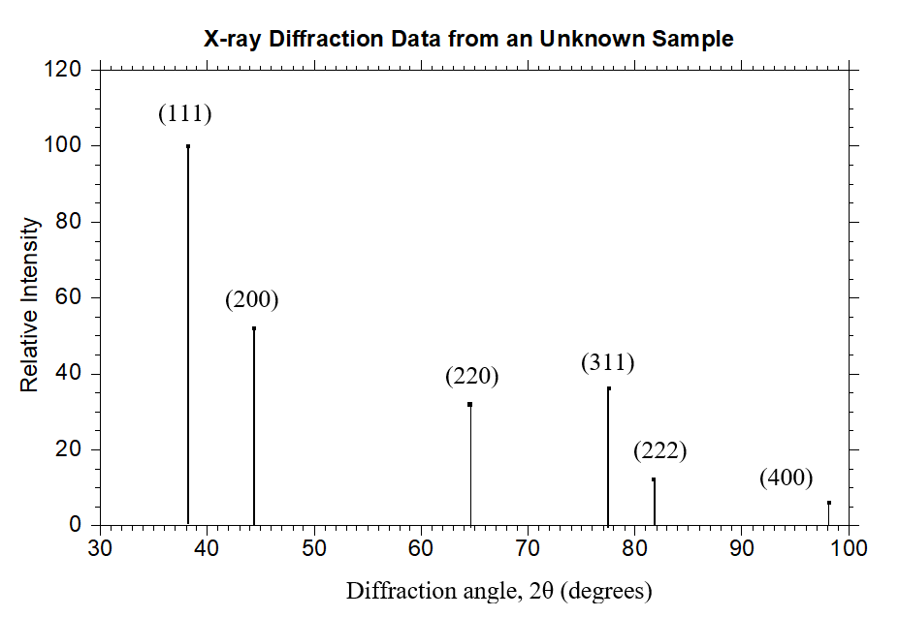

Using this diffraction pattern, answer the following questions:
- Justify why this x-ray diffraction pattern is from an FCC crystal structure. the relative intensity decreases as diffraction angle increases.
- Calculate the interplanar spacing, d, by choosing one of the diffraction peaks from the data and using Bragg’s Law. 0.1639*10^-9
- Calculate the lattice parameter, a, using the interplanar spacing equation discussed in lecture. 0.3278*10^-9
- Calculate the atomic radius, R, of the atom. 0.1639*10^-10
- Go to the inside cover of your textbook and select the best option for the “unknown” metal and provide justification for your answer. Palladium? It has the closest lattice parameter and radius

(1 pts) 4. The metal iridium has an FCC crystal structure. If the angle of diffraction for the (220) set of planes occurs at 69.22º when monochromatic x-ray radiation having a wavelength of 0.1542 nm is used for the measurement, compute the following and show your work:
- the interplanar spacing 0.1639*10^-9
- the atomic radius for an iridium atom 0.08195x10^-9

(1 pts) 5. The metal rubidium has a BCC crystal structure. If the angle of diffraction for the (321) set of planes occurs at 27.00º when monochromatic x-ray radiation having a wavelength of 0.0711 nm is used for the measurement, compute the following and show your work:
- the interplanar spacing for this set of planes 0.0783*10^-9
- the atomic radius for a rubidium atom 0.0678*10-9

(4 pts) 6. The following diffraction pattern is from a specimen of copper and was collected with monochromatic x-ray radiation having a wavelength of 0.1542 nm.

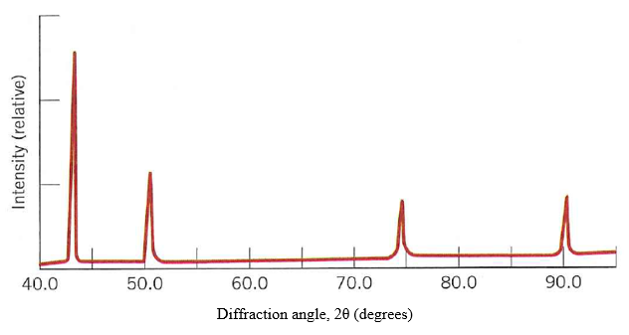
Using this pattern, complete the following table:

Peak Number  (from left to right) | θ (degrees) | Peak Index (h k l) | d (nm) | Calculated  R_{copper} (nm)
1
2
3

Hint: if you performed all the calculations correctly, the values for the calculated radius of copper should be nearly identical to the “known” value (i.e., on the inside cover of your textbook).

